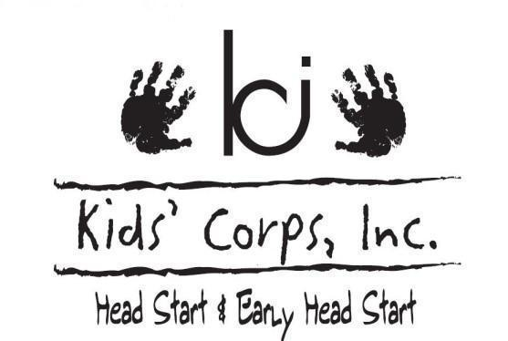
Preservice Week Agenda 2021
Monday- August 16th  Loussac Library  Learning Commons  ALL STAFF | Tuesday – August 17th  Loussac Library  TEACHING STAFF | Wednesday – August 18th  Loussac Library  Learning Commons  TEACHING STAFF | Thursday – August 19th  Loussac Library  Learning Commons  TEACHING STAFF AM  ALL STAFF PM | Friday – August 20th  Loussac Library  Learning Commons  ALL STAFF | ALL STAFF MUST COMPLETE  Due End of Day Friday to Supervisor
8:30 – 10:30 am  Welcome & Introductions  What is a school family  BREAK 10:30 - 10:45am  10:45 – 11:30 am  Health Protocols  11:30 - 11:45am  Personnel Updates  LUNCH 11:45-1:00pm  1:00-1:45pm  Medication Administration, & Classroom Health Plans  1:45-2:45pm  Parenting Curriculum  BREAK 2:45-3:00pm  3:00-4:00pm  Disabilities Overview | 8:30am – 3:30pm  Implementing The Creative Curriculum for Preschool and for Infant Toddlers Twos  (Ts, ATs, CDs)  Two sessions running simultaneously.  HS Staff - Learning Commons  EHS Staff - Beluga Meeting Room | 8:30am – 11:30am  Using Observations of Children to Analyze and Respond  (ALL Ts, ATs, and CDs)  LUNCH 11:30-12:45pm  12:45 - 1:45pm  Speech Language with  Nancy Lovering confirmed  (ALL Ts, ATs, and CDs)  1:45-3:15pm  CACFP Meal Services  (ALL Ts, ATs, and CDs) | 8:30am – 11:30am  Using Observations of Children to Analyze and Respond  (ALL Ts, ATs, and CDs)  LUNCH 11:30 - 12:45pm  12:45-1:15pm  Child Abuse Neglect Infants and Toddlers  1:15-2:45pm  Conscious Discipline Implementation | 8:30am – 12:30pm  Wellness- Individually and In A School Family with Shawna Ragan  LUNCH 12:30-2:00pm  2:00-4:00pm  Active Supervision Rotation at East Center  - Active Supervision & Child Guidance  - Playground Transition  - CAN Reporting Process  - Sanitation | On Own  Complete Online Trainings  - Personnel forms packet  - DEED Mandated Reporters of Child Abuse Neglect 1.5 hours  - Cribs for Kids Safe Sleep Ambassador Certification 1 hour  - DEED Precautions Against Blood borne Pathogens 1 hour  - Emergency Preparedness 1 hour

